PETROVIETNAM FERTILIZER AND CHEMICALS CORPORATION |  | SOCIALIST REPUBLIC OF VIETNAM
SOUTH-EAST PETROVIETNAM FERTILIZER AND CHEMICALS JOINT STOCK COMPANY |  | Independence - Freedom – Happiness
No. /DNB - BOD Ho Chi Minh City, January , 2025
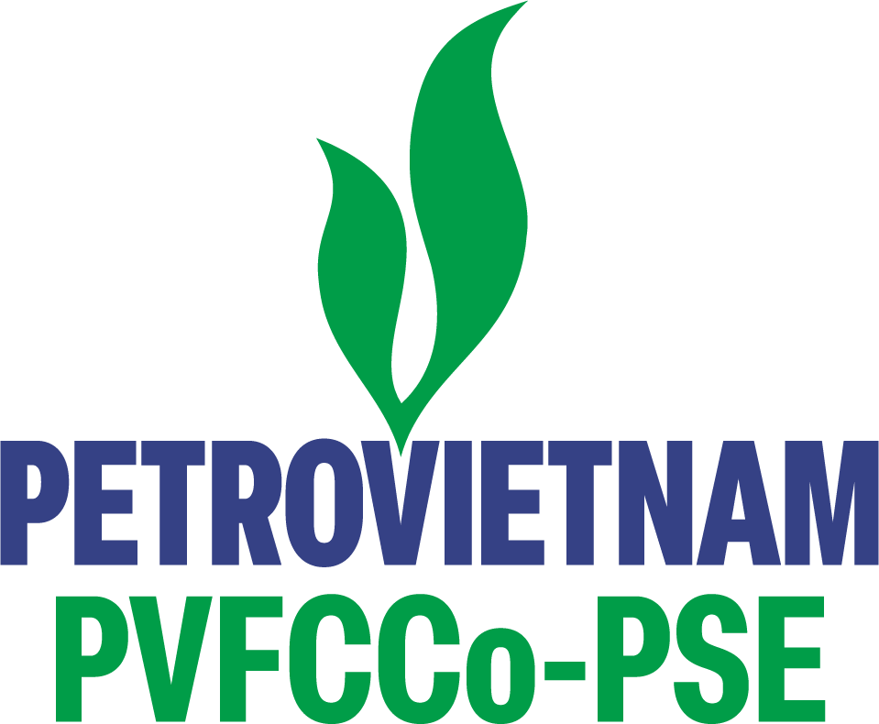
Re: Notice of Change of Company Seal Sample
To:
- The State Securities Commission;
- Hanoi Stock Exchange
- Information Disclosure Organization:
- Organization name: South-East PetroVietnam Fertilizer and Chemicals Joint Stock Company
- Stock code: PSE
- Head Office: No. 27 Dinh Bo Linh Street, Binh Thanh Ward, Ho Chi Minh City.
- Telephone: 028.35 111 999 Fax: 028.35 111 666
- Person in charge of information disclosure: Mr. Nguyen Cong Bang – Deputy General Director of the Company.
- Type of disclosed information: 24H
- Content of disclosed information:
South-East PetroVietnam Fertilizer and Chemicals Joint Stock Company announces the change of the Company’s official seal:
- Effective date: from February 1st , 2026.
- New Seal Sample:

- Website address for information disclosure: http://pse.vn/
We hereby certify that the information disclosed above is true and accurate, and we take full legal responsibility for the contents disclosed herein.
Sincerely!

Recipients:  - As above;  -BOD, Director, BOS (for reporting);  - Website Editorial Board  (for posting news);  - Archived Documents, HM.01. | PERSON IN CHARGE OF INFORMATION DISCLOSURE  DEPUTY GENERAL DIRECTOR  Nguyen Cong Bang

